Guided Reading Chapter 3 Sections 2 & 3

1. What is the difference between *relief* and *elevation*?
2. Sea level is the _____________ _________between high and low tides.
3. A _______________________ map shows elevation of the land.
4. city b) bathymetric c) topographic
5. Contour lines reveal areas with the ___________ elevation.
6. What is the contour interval?

320 m

300 m

1. Complete the table showing the various symbols on a map.

|  |  |
| --- | --- |
| Topographic contour | River |
| Campground | Lake |
| Railroad track | Highway |
| School | Woodland |
| Many buildings | Orchard |

1. When contour lines are close together on a map, they reveal a (*gentle, steep*) sloping of the land.
2. What do bathymetric maps show?
3. ___________ blue on a bathymetric map show areas that are shallow.
4. Echo sounding is technology that is used to determine ocean
5. depth b) current c) salinity

Teachers Guide

1. Relief depicts the distance between highs and lows on a map. Elevation is the height of an object measured from a reference point, usually sea level.

2. halfway point

3. c, topographic

4. same

5. 10 meters

6.

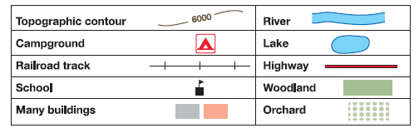

7. steep

8. Bathymetric maps show the depth of the water in an ocean. These values indicate where valleys or mountains occur.

9. Light

10. a, depth